Lab 1-1: Installation and usage of Dev-C++ and online compilers

Objective:
The objective of this lab is to teach students how to install and use the Dev-C++ and online compilers.

Learning Outcomes:
After this lab, the students will be able to run the C++ code in Dev-C++ and the online compilers.

Problem Statement

You are required to install any version of Dev-C++ in your system according to your system and operating system requirements.

Dev C++ 4.9.9.2 Installation Guide
Installation Steps:
Step 1:
Double-click on the file devcpp_setup.exe and Click on the “Run” button.



Step 2:
Click on the “OK” button.

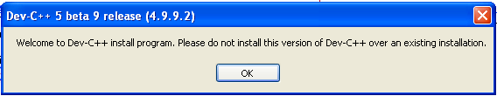

Step 3:
Click on the “OK” button.

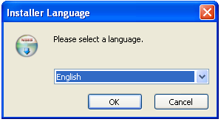
Step 4:
Click on the “I Agree ” button.
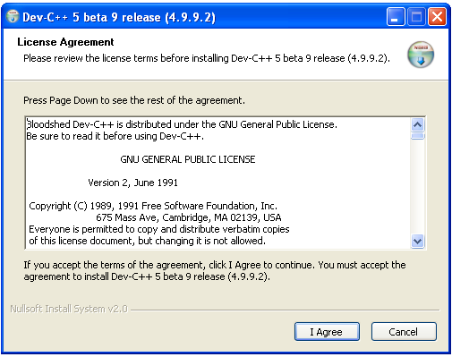
Step 5:
Click on the “Next” button.

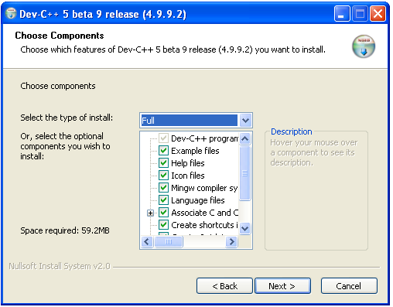

Step 6:
Click on the “Install” button.

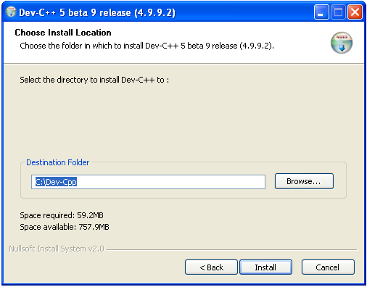
Step 7:
Wait until the green bar completed
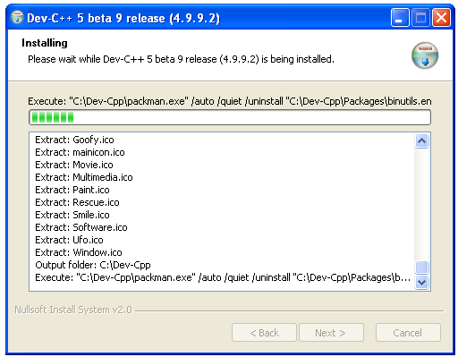

Step 8:
Click on the “Finish” button.
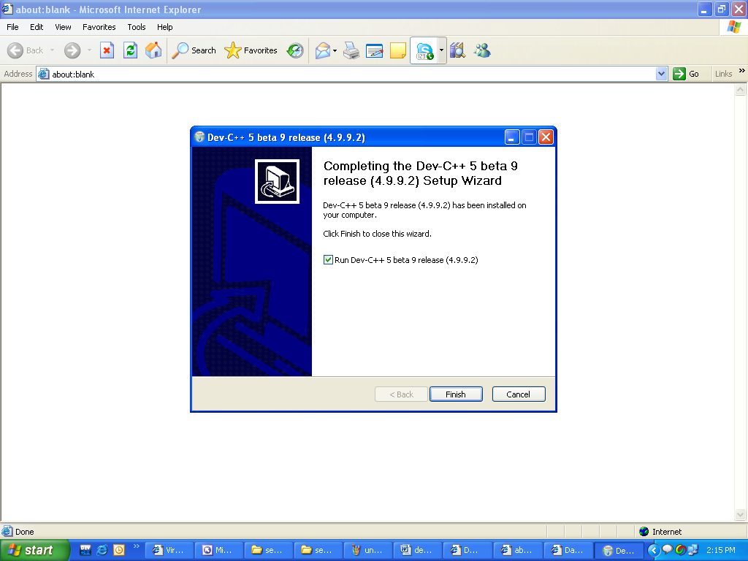

Your Dev C++ 4.9.9.2 has been installed successfully. Now start writing compiling and running programs and enjoy programming.

Dev C++ 5.9 Installation Guide

Installation Steps:

Step 1:
Double-click on the file devcpp_setup.exe and Click on the “Run” button.

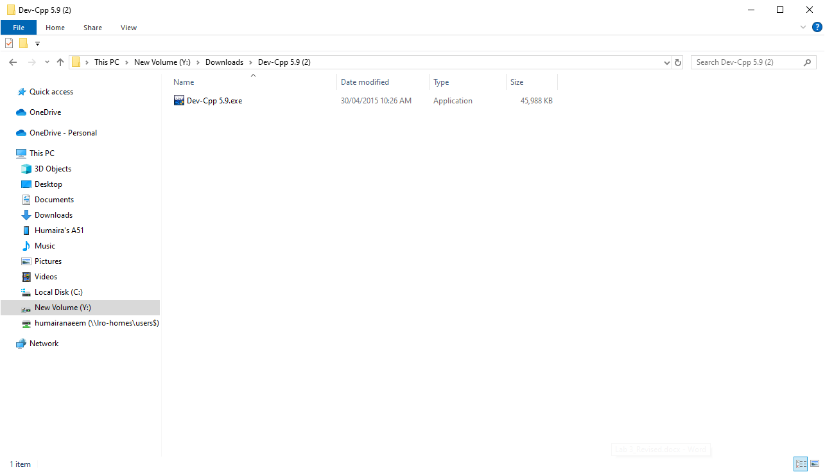

Step 2:
Click on the “OK” button.
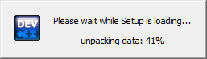

Step 3:
Click on the “OK” button.

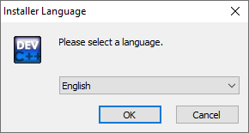
Step 4:
Click on the “I Agree ” button.

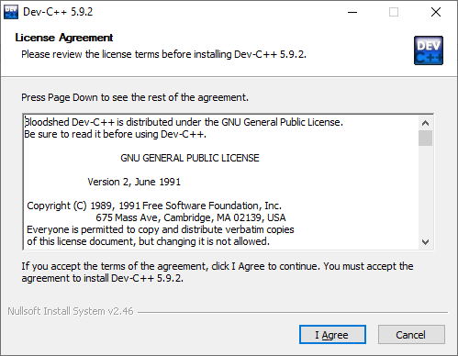

Step 5:
Click on “Next” button.

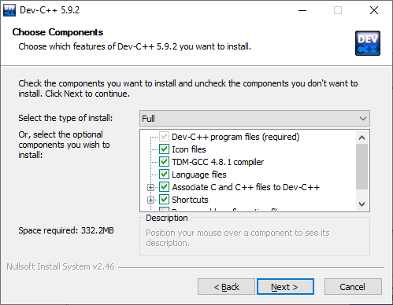

Step 6:
Click on “Install” button.
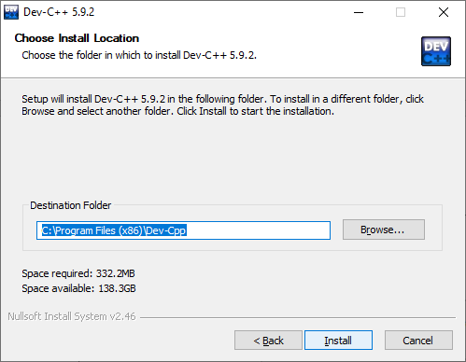
Step 7:
Wait until the green bar completed
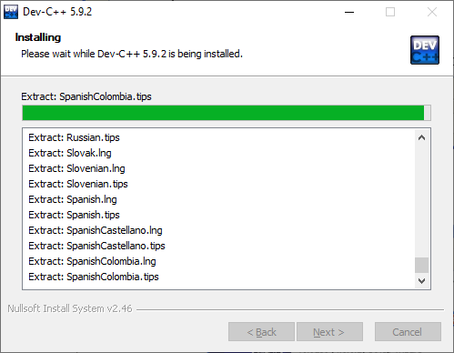
Step 8:
Click on “Finish” button.
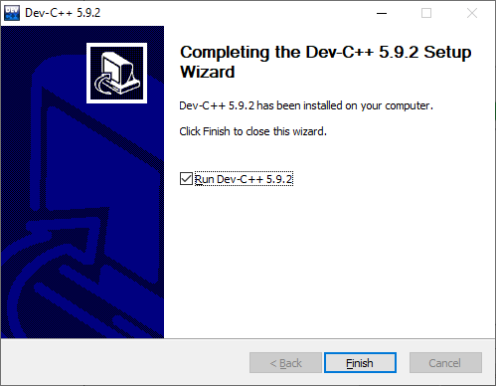
Your Dev C++ 4.9.9.2 has been installed successfully. Now start writing compiling and running programs and enjoy programming.

Guidelines on how to use Dev-C++

Following are the steps to write, save, compile, and run a program, using Dev-C++:

How to open Dev-C++:

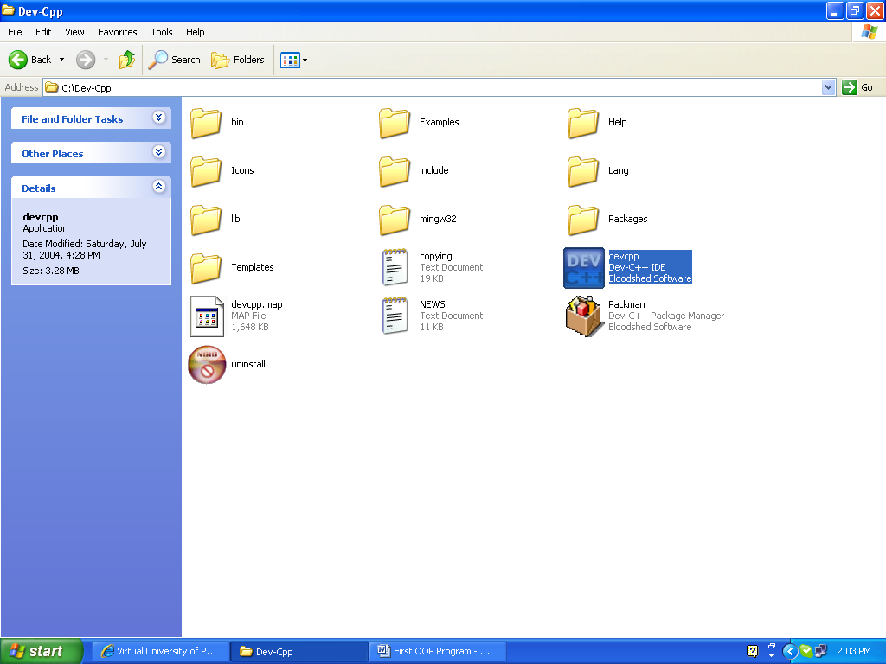

Main interface of Dev-C++:

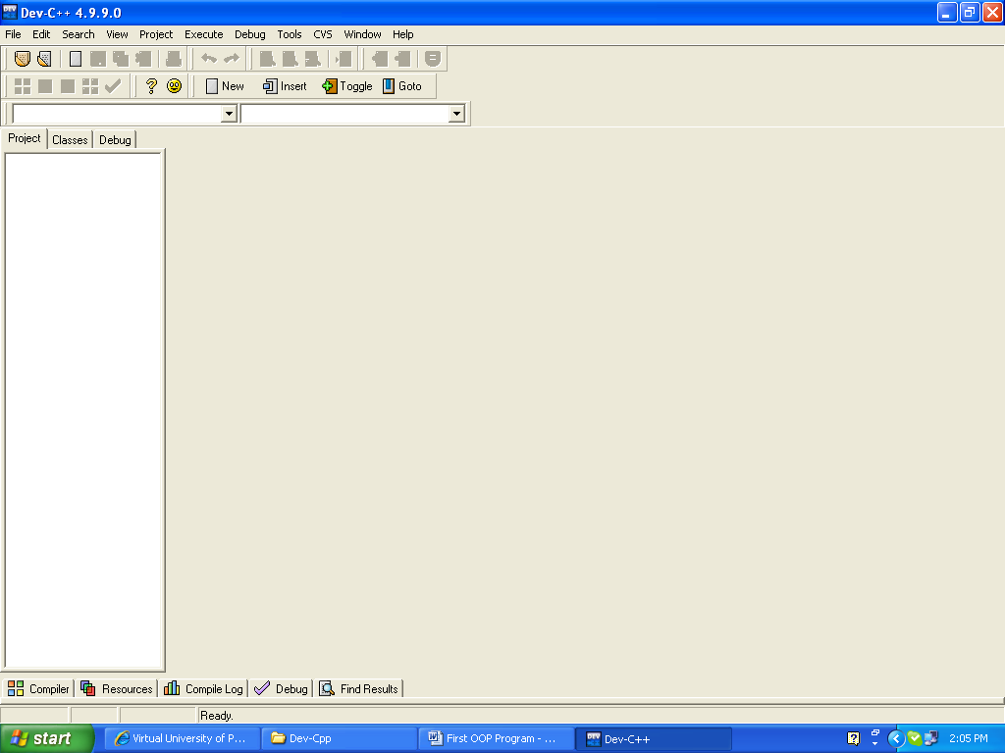

Write a new Program:

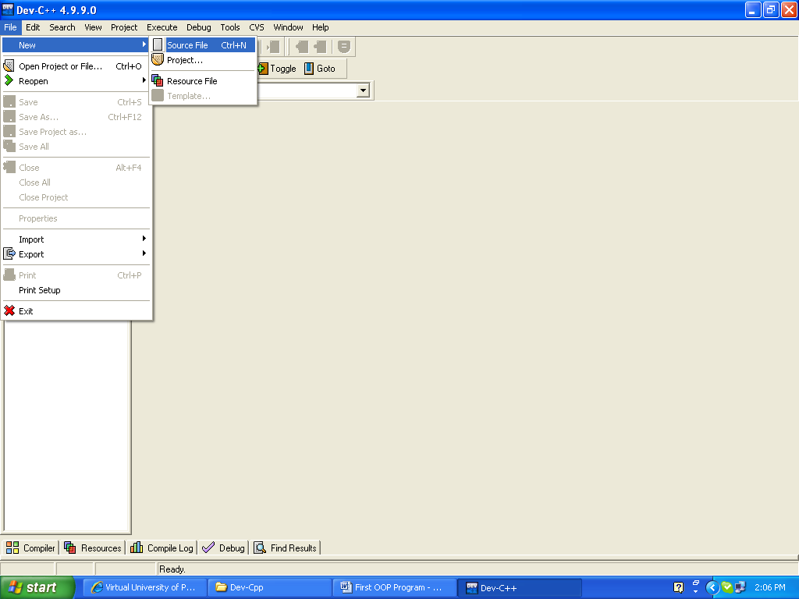

Where to write the code:

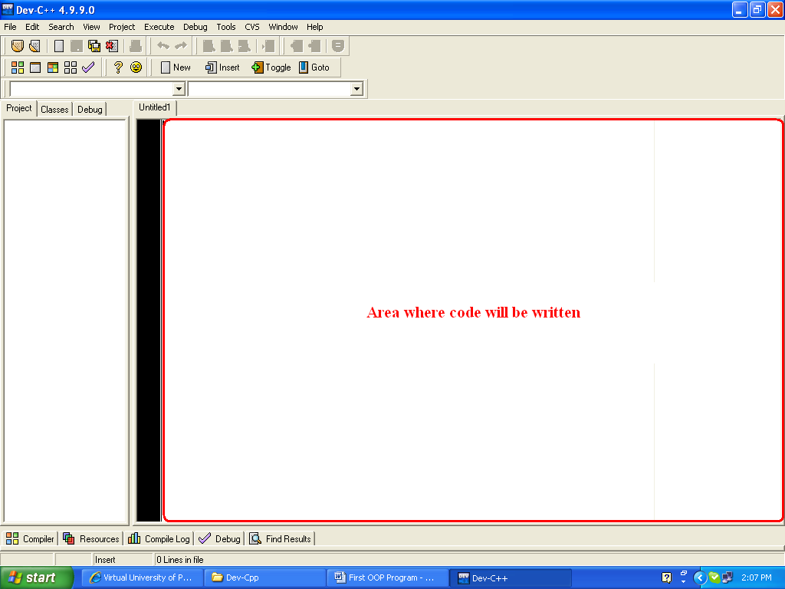

After writing your code:

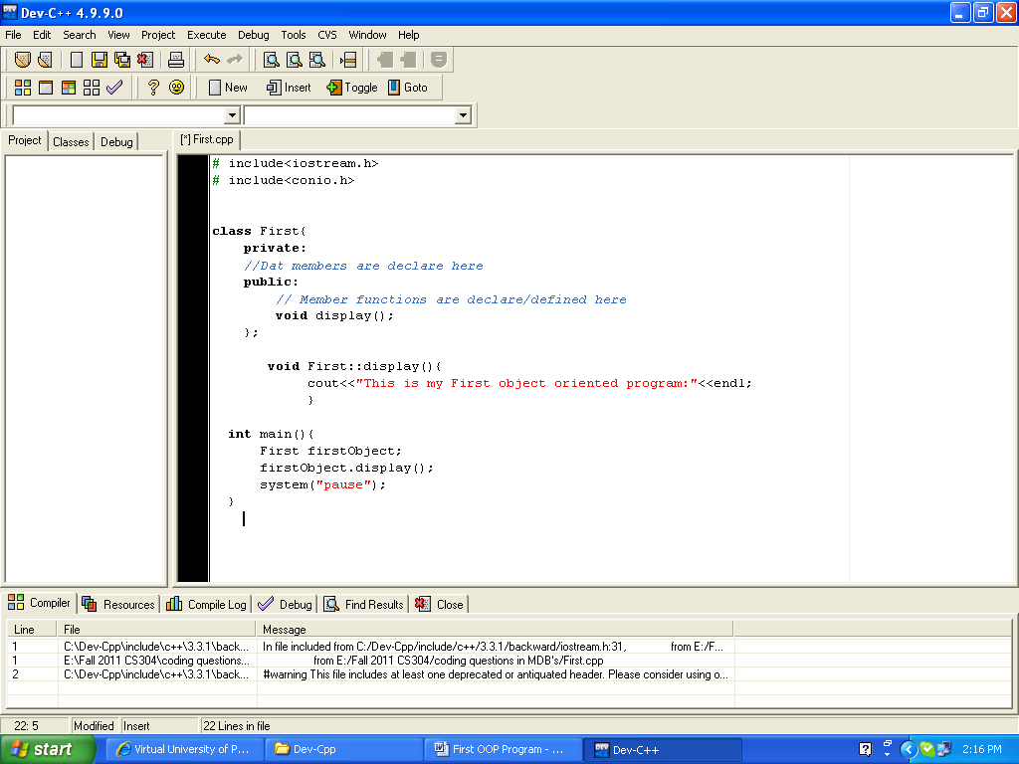

Save the Program:

1st Step:

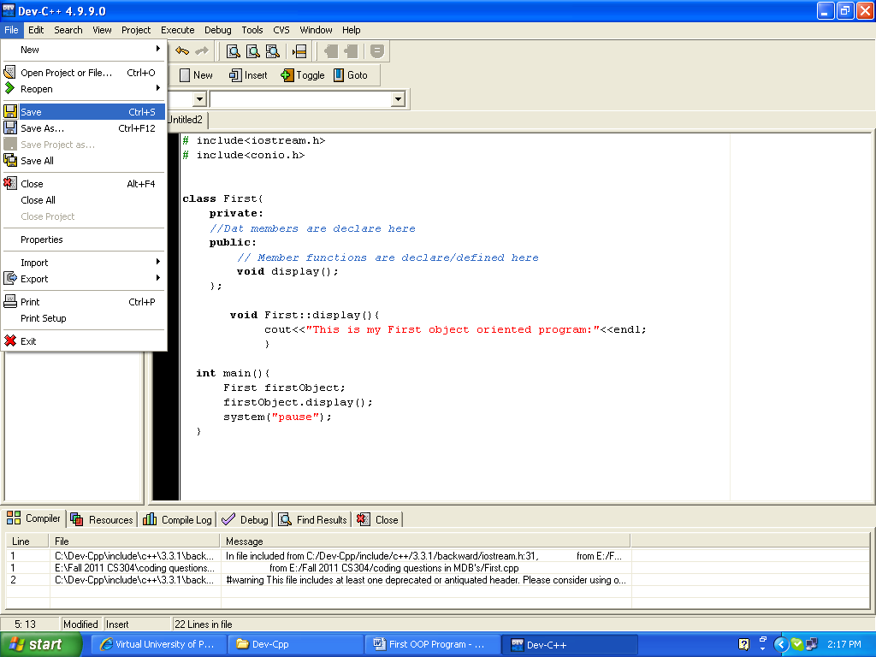

2nd Step:

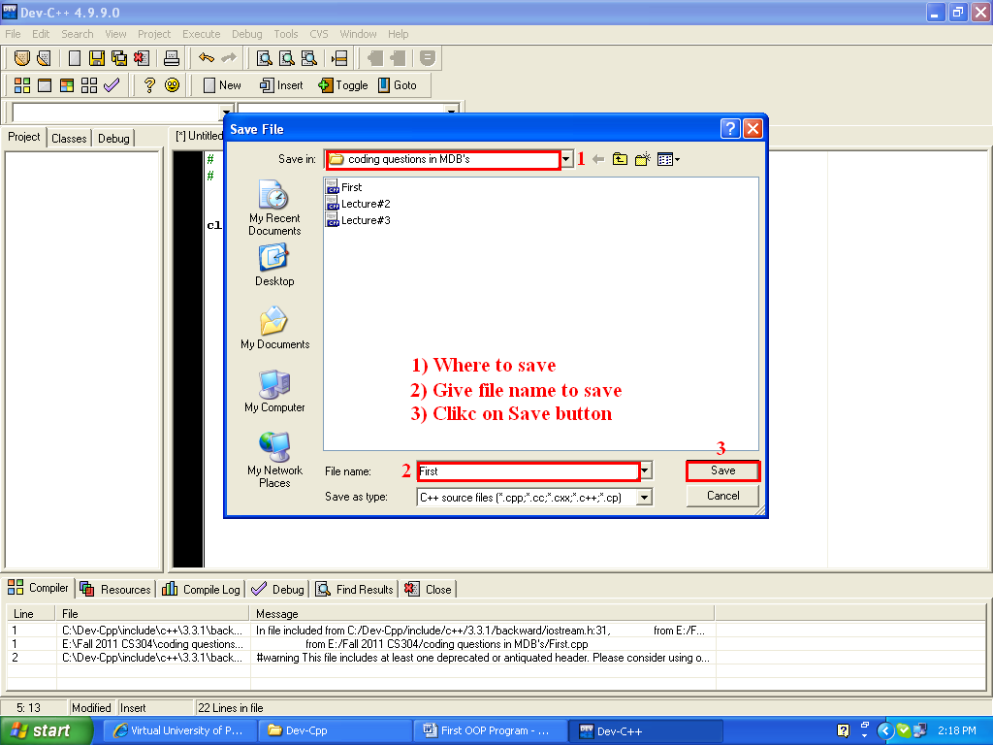

How to compile the program:

1st Step:

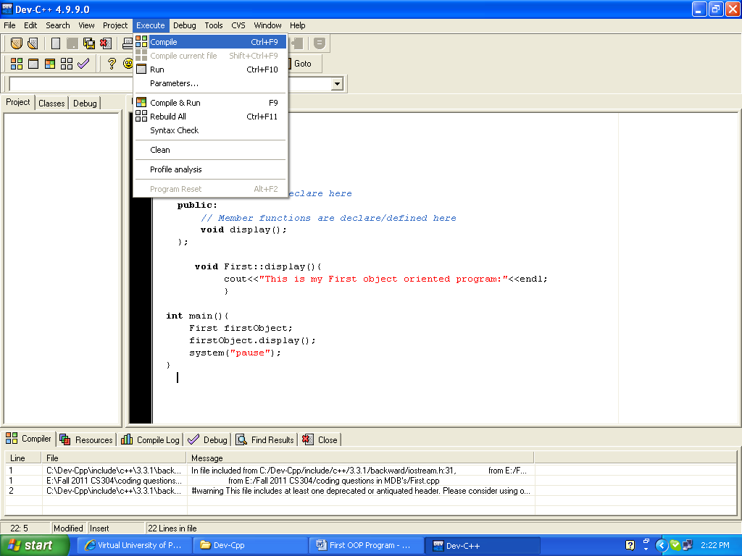

2nd and 3rd step will be performed automatically
2nd Step:

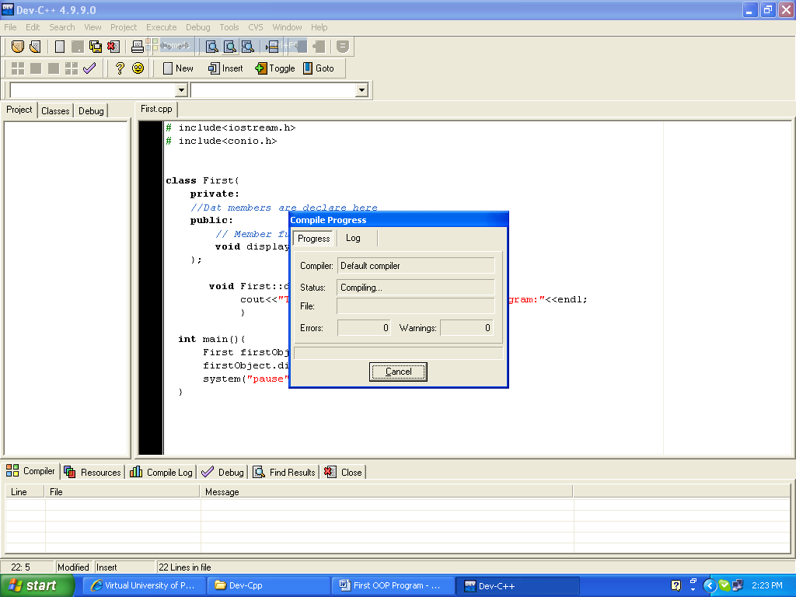

3rd Step:

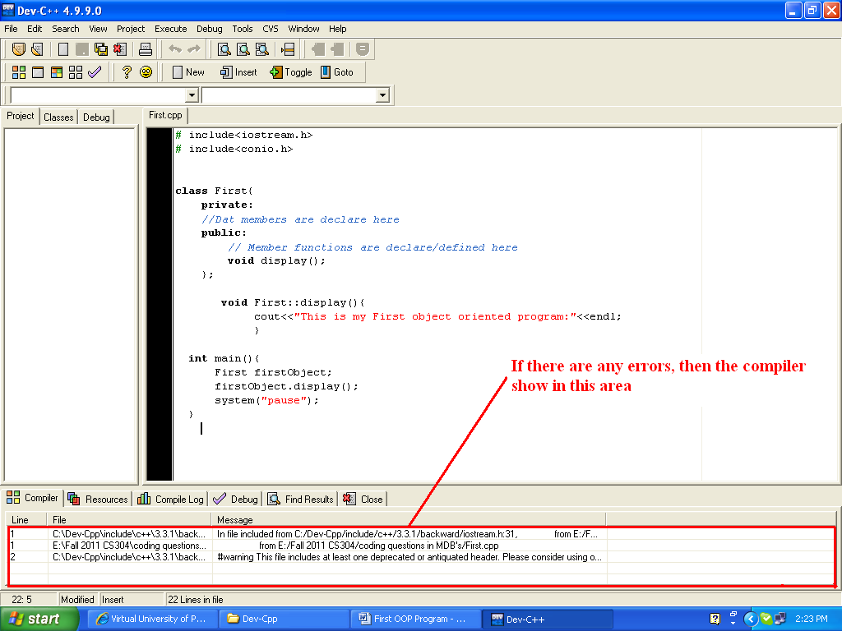

How to run the program:

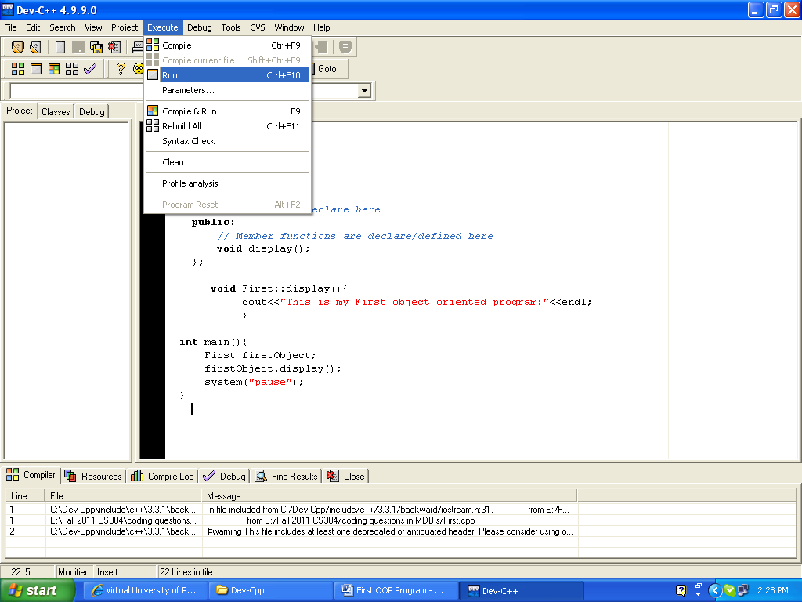

Output will be displayed as:

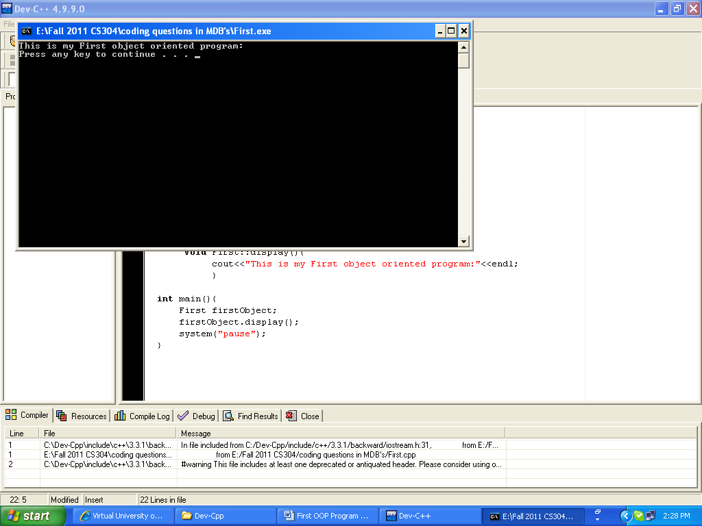

Guidelines on how to use online C++ compiler

Following are the steps to write, compile, and run a program using an online compiler:

Open a browser and type the following address in the address bar.
https://www.programiz.com/cpp-programming/online-compiler/

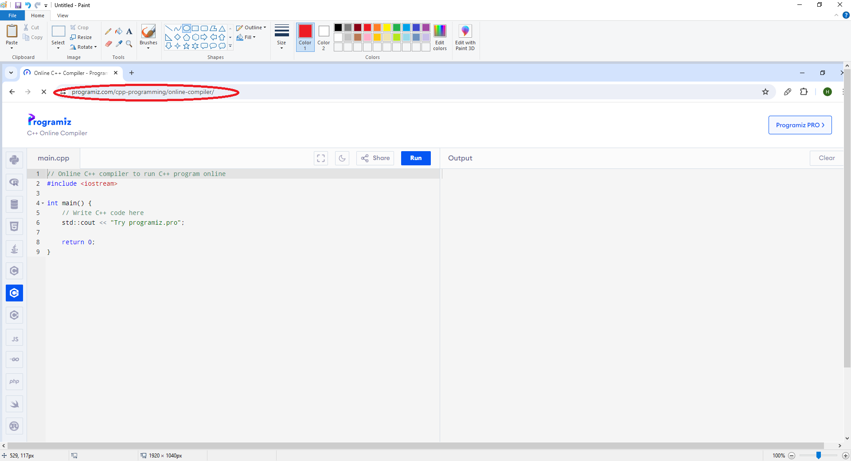

Now, write the C++ code in the highlighted area.
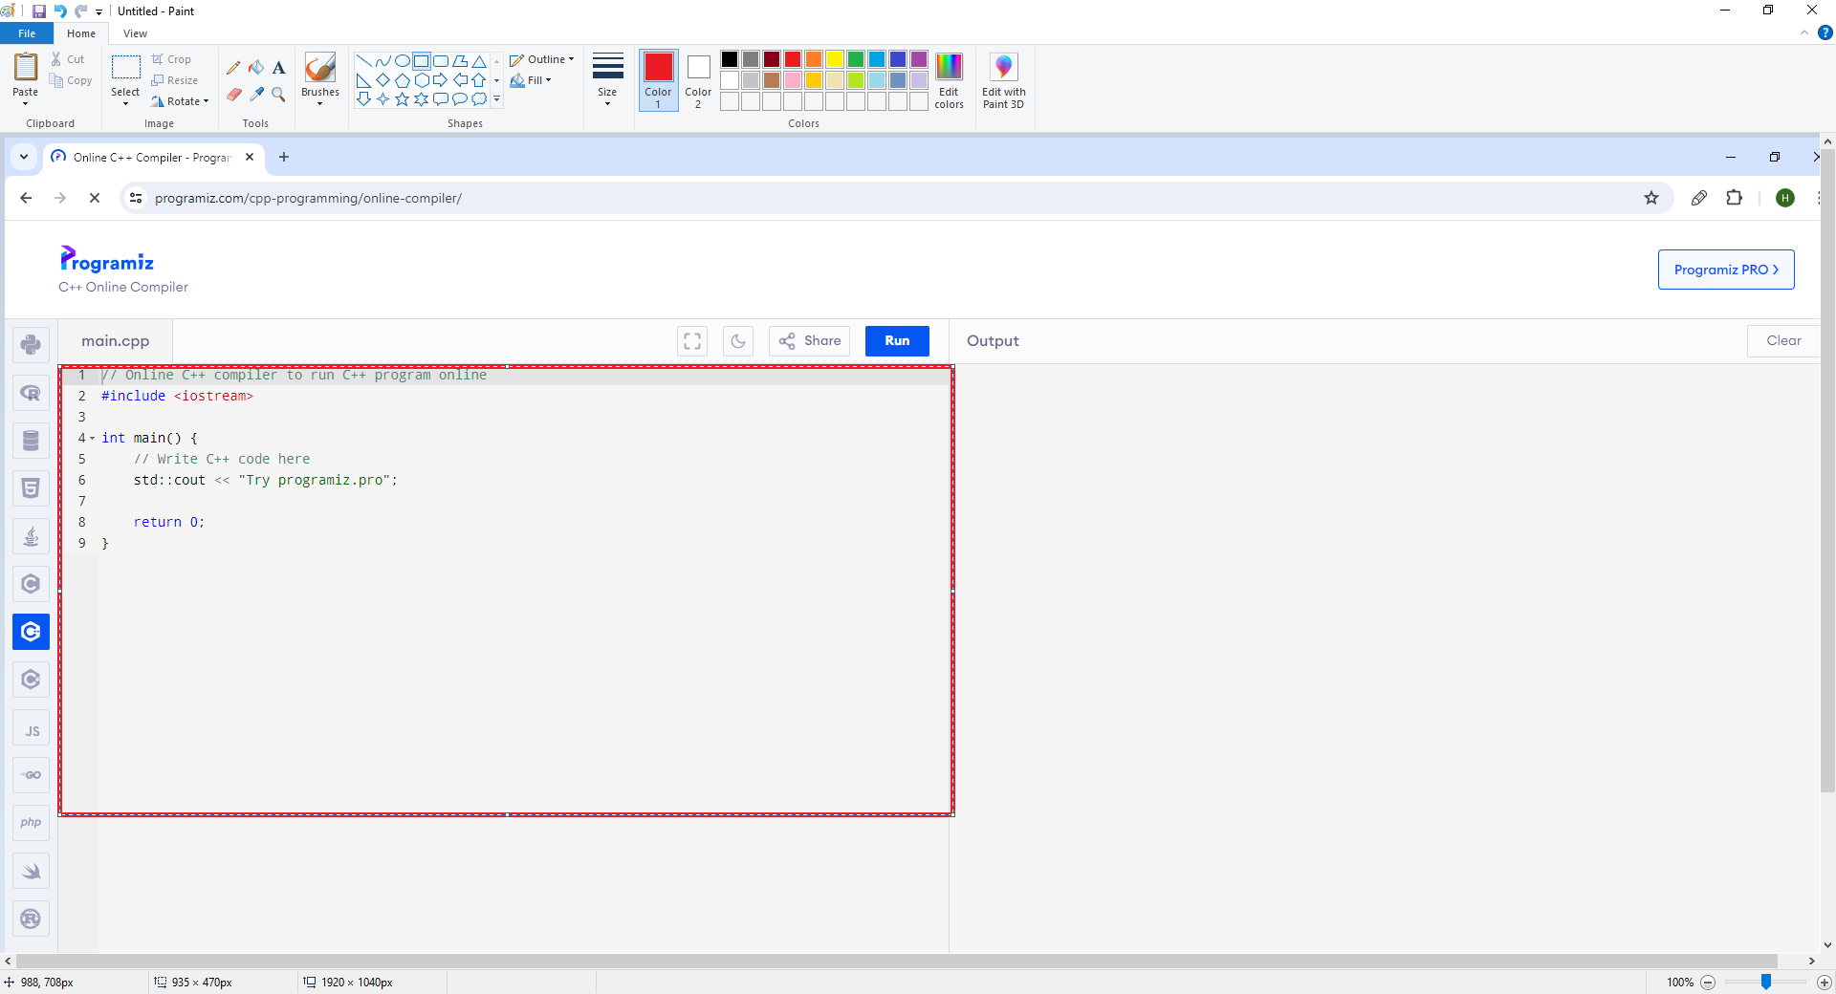

Write your C++ code in the highlighted area.

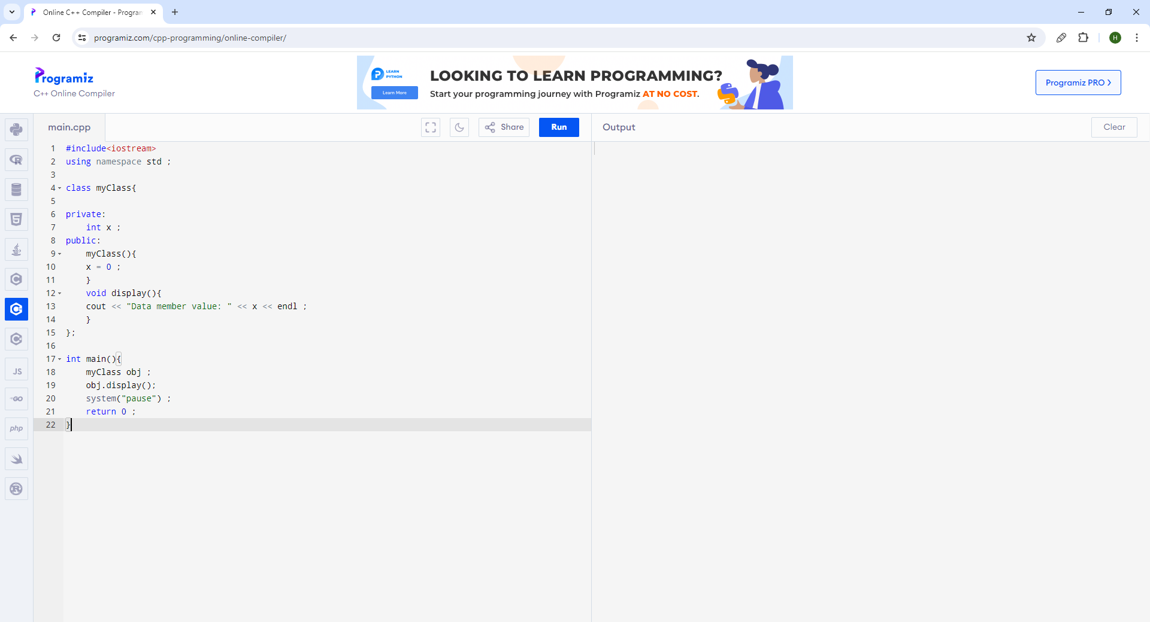
After writing the code, click on the ‘Run’ button.

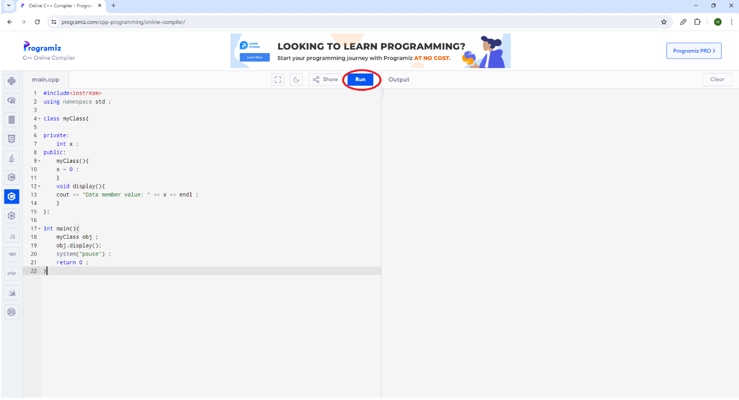

The output of the code will be shown in the highlighted area.

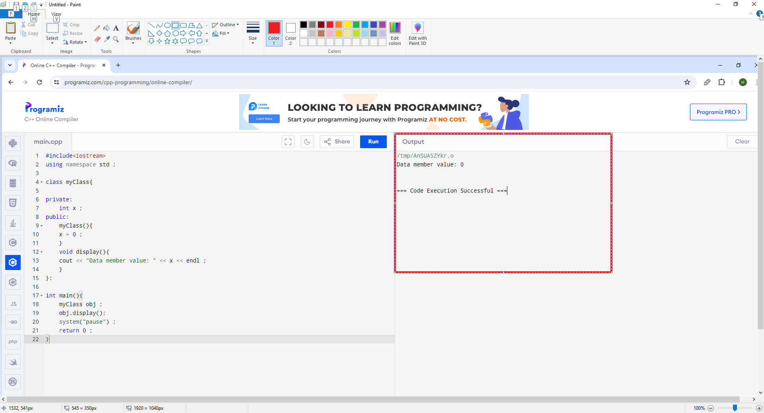
If the program contains syntax errors, then errors will be shown along with the line number in the highlighted area.

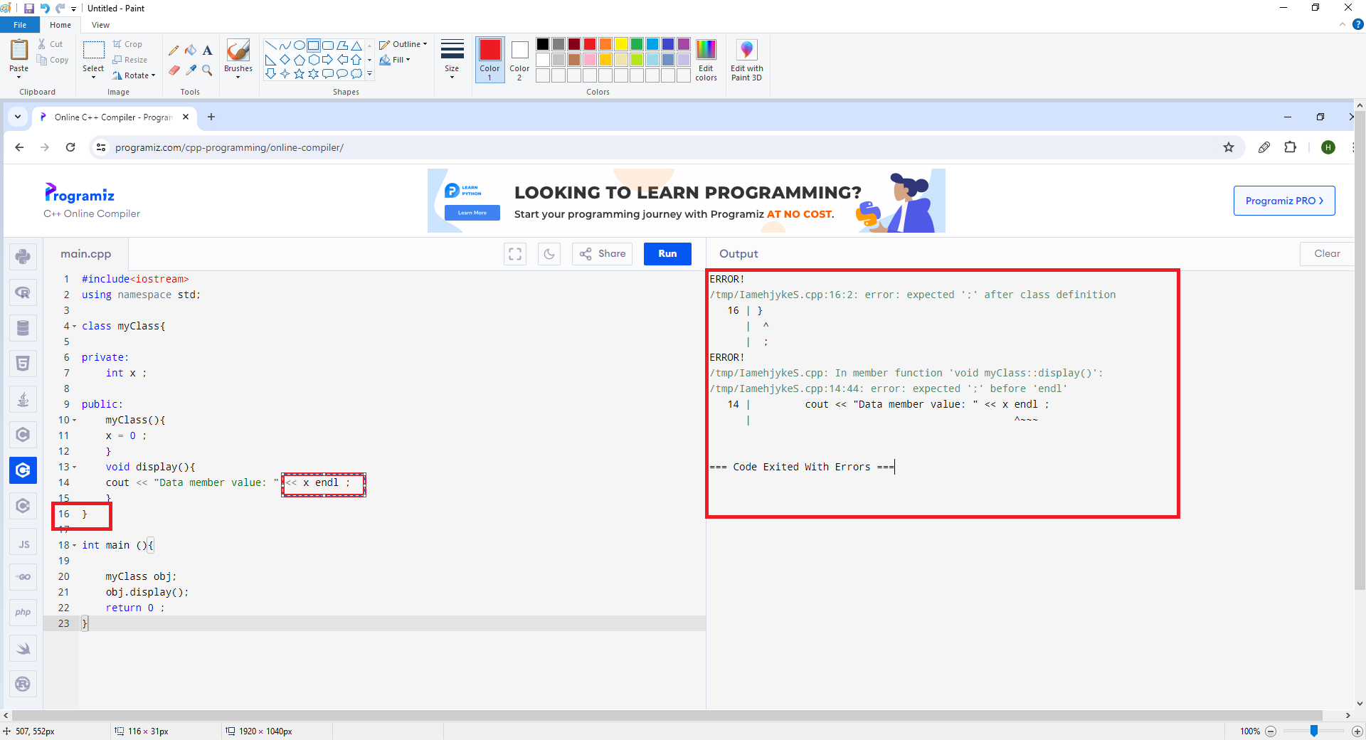

After removing the syntax errors, click on the ‘Run’ button again to see the output.

Lab 1-2: Object Orientation
Objective:
The objective of this lab is to teach students how to identify objects, their attributes and behaviors from the real-world scenario.
Learning Outcomes:
After this lab, the students will be able to identify objects, attributes and behaviors from a given scenario.

Problem Statement
Consider the following scenario and identify all objects, their attributes, and behaviors.
In the Virtual University bookshop, the handouts of all courses are provided at reasonable prices. The handouts are made in accordance with the video lectures recorded by famous professors. It is a step to facilitate students to easily digest the course contents.
You are required to extract the Class Name, attributes and behaviours (operations) from the above scenario.

Class Name | Attributes (characteristics) | Behaviors (operations)

Practice Questions:
Scenario 1:
An e-commerce website wants to allow users to browse products, add them to a cart, place orders, and make payments. Design a system that models this flow using Object-Oriented Programming principles.

Scenario 2:
You are developing a system for a bus company where passengers can view available routes, book seats, and receive tickets. The system also allows the company to schedule and manage buses.

Scenario 3:
Create a system to manage a school’s academic operations. It should handle student enrollment, teacher assignments, course schedules, and grade reporting.

Scenario 4:
A bank account can be categorized as a saving account or a current account. Any account has some amount in it and unique account id. Bank accounts are used for money transfer.

You are required to do the following tasks for the above scenarios:

- You have to identify the main entities (objects) for this system.
- You will have to find the necessary attributes and functions that need to be associated with each object to implement the functionality mentioned above. Use your domain knowledge as well for the extraction of attributes and operations.

Lab 2: Class Diagram
Objective:
The objective of this lab is to teach students how to identify classes and relationships between classes and draw a UML class diagram by applying the concepts of inheritance, aggregation and composition.

Learning Outcomes:
After this lab, the students will be able to draw a UML class diagram for a given scenario.

Problem Statement

Consider a scenario of an Employee Management System that is used to manage employee records and departments. The system handles various types of employees and departments.
Employees in the organization can be of different types, such as Full-Time and Part-Time.
Full-time employees get a salary according to their designation whereas part-time employees get a salary based on working hours. A Department contains multiple employees, but an employee is associated with only one department at a time

You are required to apply the concepts of inheritance, aggregation, and composition to the given scenario and draw a UML class diagram.

Practice Questions:

Scenario 1:
In a university system, there are various types of people such as students and professors, both of whom share common characteristics like name, age, and contact details. These shared features can be represented using a base class called Person, with Student and Professor as subclasses inheriting from it. Each professor and student is associated with a Department, which means the department aggregates multiple students and professors—however, they can exist independently if removed from the department. Additionally, each student has a Transcript that records their academic performance. This transcript is tightly bound to the student and does not exist independently.

You are required to apply the concepts of inheritance, aggregation or composition to the above given scenarios and draw a UML class diagram.

Scenario 2:
In a library management system, the core entities include books, members, and staff. Each Book consists of several Chapters, and the existence of chapters is entirely dependent on the book—if the book is removed, its chapters are too. The system distinguishes between different kinds of members such as AdultMember and ChildMember, both of which inherit from a general Member class that contains shared details like member ID and contact info. A Librarian in the system is responsible for managing the Catalog and issuing books to members. While the librarian may maintain a list of issued members, the members themselves can exist independently.

You are required to apply the concepts of inheritance, aggregation or composition to the above given scenarios and draw a UML class diagram.

Scenario 3:
In an e-commerce system, users interact with the platform in different roles. A base class called User can be defined to capture common details like username and password. From this base, two specialized classes can be derived: Customer and Admin. A Customer has a ShoppingCart that holds selected products; the cart is created specifically for the customer and does not exist on its own. The ShoppingCart contains multiple Product instances. Each product belongs to a particular Category, such as electronics or clothing. The category organizes the products but does not own them.

You are required to apply the concepts of inheritance, aggregation or composition to the above given scenarios and draw a UML class diagram.

Lab 3: Constructor overloading and copy constructor
Objective:
The objective of this lab is to teach students how to overload constructors, deep copy constructors, and destructors in a class.
Learning Outcomes:
After this lab, the students will be able to overload constructors, copy constructors, and destructors.

Problem Statement
Write a C++ program that consists of a class named Employee having the following data members:
- Employee id
- Employee name
- Employee salary

The class should have the following member functions:
- Setters and getters functions
- Default constructor
- Parameterized constructor
- Deep copy constructor
- Destructor to deallocate the memory
- Display () function

Within the main () function, create an object emp1 of class Employee and initialize its data members using a parameterized constructor. Within the constructor, you have to call the setters functions to set the values of these data members.

Now, create another object emp2 and initialize it with emp1 using the deep copy constructor.
After that, you have to call the display () function to show the data members of both objects.

Sample Output:

After running your program, the following screen should display.

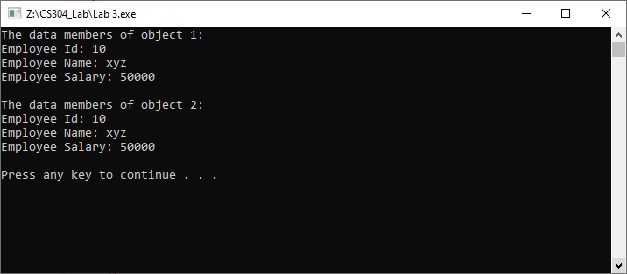

Practice Questions:
Question No. 1
You are required to add the following three constructors in the above program:
- Constructor with one parameter (id)
- Constructor with two parameters (id, name)
- Constructor with three parameters (id, name, salary)

Within the main () function, create an object emp1 of class Employee and initialize its data member id using a constructor with one parameter. Create another object emp2 of class Employee and initialize its data members (id and name) using a constructor with two parameters. Create a third object emp3 of class Employee and initialize its data members (id, name and salary) using a constructor with three parameters.

After that, you have to call the display () function to show the values of all three objects.

Question No. 2

Write a C++ program that consists of a class named Book having the following data members:

- Book ID
- Book Title
- Book Author

The class should have the following member functions:
- Setters and getters functions
- Default constructor
- Parameterized constructor
- Display () function

Within the main () function, create an object book1 of class Book and initialize its data members using a parameterized constructor.
Now, create another object book2 and initialize it with book1.
Then, change the title of book2 and call the display () function to show the data members of both objects.

Lab 4: Constant and static members in classes
Objective:
The objective of this lab is to teach students how to define and use constant and static members in classes.
Learning Outcomes:
After this lab, the students will be able to define and use constant and static members in classes.

Problem Statement
Write a C++ program that creates a class named Employee having the following data members:
- A static data member “count” to store the total number of Employee objects
- Employee ID as a const data member

The class should contain the following member functions:
- Constructor and destructor
- Static member function to get the value of count
- Const member function to get the value of employee ID

In the main () function, create three objects e1, e2, and e3 of type Employee and initialize the value of employee id.

Also, create a constant object ‘e4’ of an Employee class and initialize the employee ID.

For each object, print the value of Employee ID using the const member function.
At the end of program, display the value of the “count” data member showing the total number of employees.

Sample Output:

Following is a sample output for the above scenario:

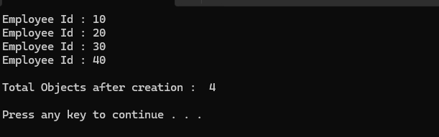

Practice Questions:
Problem Statement 1
Write a C++ program that creates a class named Book having the following data members:
- Book Id
- Book title
- A static data member “count” to store the total number of Books

You are required to initialize the static data member count to initial value 1.

The class should contain the following member functions:
- Constructor and destructor
- Static member function to get the value of count

In the main () function, create two objects book1 and book2 of type Book and initialize the value of data members of class.

At the end of program, display the value of the “count” data member showing the total number of books.

Problem Statement 2
Write a C++ program that creates a class named Book having the following data members:
- Book ID as a const data member
- Book title

The class should contain the following member functions:
- Constructor and destructor
- Setters and getters functions
- Const member function to get the value of book id

In the main () function, create two const objects book1 and book2 of type Book and initialize the value of data members of class.

At the end of the program, you have to display the value of data members.

Lab 5: Composition
Objective:
The objective of this lab is to teach students how to implement composition relationship between classes using C++ code.
Learning Outcomes:
After this lab, the students can write C++ code for the composition relationships between classes.

Problem Statement

Consider the following UML class diagram having composition relationships between classes Customer and Account.

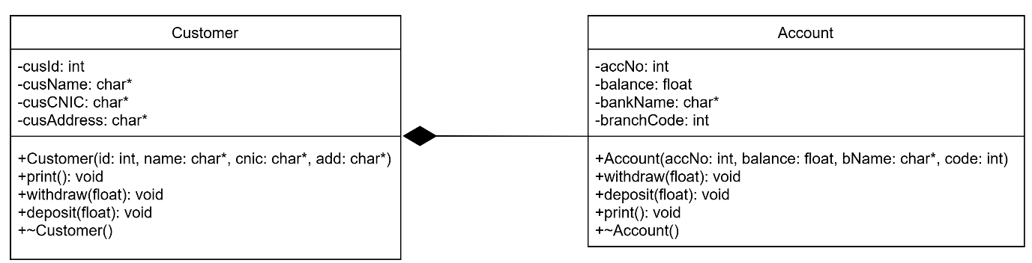

Customer class has the following data members:
- Customer id
- Customer name
- Customer CNIC
- Customer Address
- Account

The class should have the following member functions:
- Parameterized constructor
- print()
- withdraw()
- deposit()
- Destructor

Account class has the following data members:
- Account No.
- Balance
- Bank name
- Branch code

The class should have the following member functions:
- Parameterized constructor
- withdraw()
- deposit()
- print()
- Destructor

You are required to implement the composition relationship between classes using C++ code.

Within the main () function, create an object of Customer class and initialize its data members along with the Account details.
Now, call the deposit() function to deposit some amount then call the print () function which will display all the values of Customer including their ID, name, CNIC, address and account details.
Then, call the withdraw function to withdraw some amount and call the print () function which will display all the values of Customer including their ID, name, CNIC, address and account details.

Sample Output:

Following is a sample output for the above scenario:

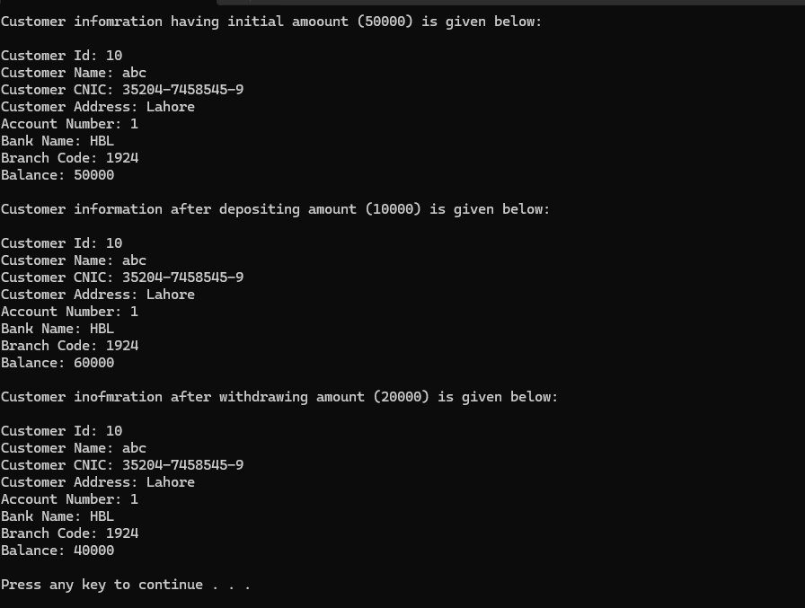

Practice Questions:
Scenario 1
Suppose you are building a Sports Team management system. A team consists of multiple players, but players can exist independently of Team.

The Player class has the following data members:
- Player id
- Player name

The class should have the following member functions:
- Constructor
- Destructor
- showPlayer()

Team class has the following data members:
- Team Id
- Team name
- Players

The class should have the following member functions:
- Constructor
- Destructor
- addPlayers()
- showPlayers()

You are required to implement the aggregation relationship between classes using C++ code.
Implement the main() function according to the functionalities given in the classes.

Scenario 2
Suppose you are building a Library management system. A Library consists of multiple books, but books can exist independently of Library.

Book class has the following data members:
- Book id
- Book Title
- Book Author

The class should have the following member functions:
- Constructor
- Destructor
- print ()

Library class has the following data members:
- Library Id
- Library name
- Books

The class should have the following member functions:
- Constructor
- Destructor
- addBooks()
- printBooks()

You are required to implement the aggregation relationship between classes using C++ code.
Implement the main() function according to the functionalities given in the classes.

Lab 6: Operator Overloading
Objective:
- The objective of this lab is to teach students how to overload some binary operators in C++.
Learning Outcome:
- After this lab, students will be able to overload +, -,*,/,+=,-=,*=,/= operators.
Problem Statement
Write a C++ program to perform the following tasks.
- Create a class named Circle. Perform following tasks for this class.
  - Add one data member radius of type double.
  - Add setter and getter functions to set and get value of radius data member.
  - Create following objects: circle1, circle2, cricle3, circle4, circle5 and cricle6
of Circle class in main() function.
  - Set radius of circle1, circle2, and cricle3 to 6.3, 4.2, and 12.5 respectively.
  - Overload the + operator for the following types of operations.
    - circle4 = circle1 + circle2
    - circle5 = circle2 + 8.23
    - circle6 = 7.4 + circle2;
  - Display radius of circle4, circle5 and cricle6.
Sample Output:
- After running your program, the following output should be displayed.
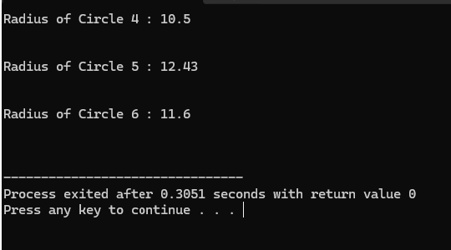

Practice Question:
- Write C++ code to overload -, *, and / operators for the given class circle.

Lab 7: Overloading stream insertion, stream extraction and unary operators
Objective:
- The objective of this lab is to teach students how to overload stream insertion, stream extraction and unary operators in C++.
Learning Outcome:
- After this lab, students will be able to overload stream insertion (<<), stream extraction (>>) operators, unary minus (-), pre-increment, post-increment, pre-decrement and post-decrement operators.
Problem Statement
A Complex number is represented as a sum of a real number and an imaginary number. Write a C++ program that consists of a class named Complex which has data members real and imag. Your task is to overload the following operators for the Complex class.
- Stream insertion operator (<<)
- Stream extraction operator (>>)
- Unary minus operator (-)
- Pre-increment operator (++)
- Post-increment operator (++)
In the main () function, do the following.
- Create an object com1 and take input using the stream extraction operator and print output using the stream insertion operator.
- Create an object com2 and print output of com2 object after executing the statement com2=-com1;
- Create an object com3 and print output of com3 object after executing the statement com3=++com1;
- Create an object com4 and print output of com4 object after executing the statement com4=com3++;
Sample Output:
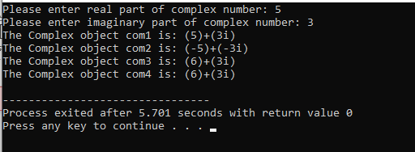

Practice Questions:
Overload Pre-decrement and Post-decrement operators for the scenario given in lab problem statement.

Lab 8: Inheritance
Objective:
- The objective of this lab is to teach students how to implement inheritance in C++.
Learning Outcome:
- After this lab, students will be able to implement inheritance.
Problem Statement
Write a C++ Program to create a base class Employee that stores the employee's name and ID. Derive a class Engineer from Employee that adds the following additional attributes:
- specialization (e.g., Software, Civil, Electrical)
- experience (in years)
- projectName (name of the current project)
The program should input and display all details of an engineer using appropriate methods. This program should demonstrate how data and behavior from the base class are inherited and extended in the derived class.
Sample Output
After running your program, the following output screen should display.
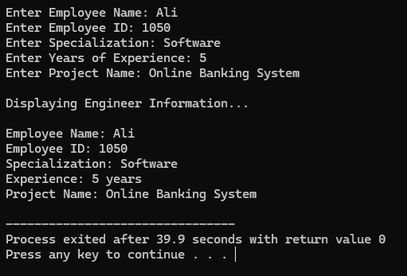
Practice Questions:
Practice Question 1:
Write a C++ program for the following:
Create a base class Book with data members: title and author. Derive a class EBook that adds fileSize (in MB) and format (e.g., PDF, EPUB). Your program should input and display all details of an EBook.

Practice Question 2:
Write a C++ program for the following:
Create a base class User with attributes username and email. It should include getter and setter functions. Derive two classes:
Admin, which adds a method accessControlPanel()
Member, which adds a method browseContent()
In main() function, create objects of both derived classes. The program should input and display the username and email using inherited methods, and then call the respective methods of the Admin and Member classes to display their specific functionalities.

Lab 09:
Objective:
- Understand and apply public, private, and protected inheritance in C++
- Observe how access specifiers affect inherited members.
- Learn how base class behavior is inherited, hidden, or overridden.
Learning Outcome:
- After completing this lab, students will be able to identify and understand the accessibility of base class data members across different types of inheritance.
Problem Statement
Write a C++ program which should consist of following four classes.
- Base
- Derived_Private
- Derived_Protected
- Derived_Public
“Base” class should consist of following data members along with following type.
Data member | Access Specifier
secret | private
protect | protected
access | public
Further, “Base” class should contain default constructor to initialize its data members.
Other three classes should be inherited from “Base” class with respect to following type of inheritance.

Class | Inheritance type
Derived_Private | Private
Derived_Protected | Protected
Derived_Public | Public
All three derived classes should contain show() function, which should display the values of secret, protect and access data member of base class. On running this program, your compiler will generate compile time errors. Carefully observe for which type of base class data member, compiler is generating error.
Class Diagram
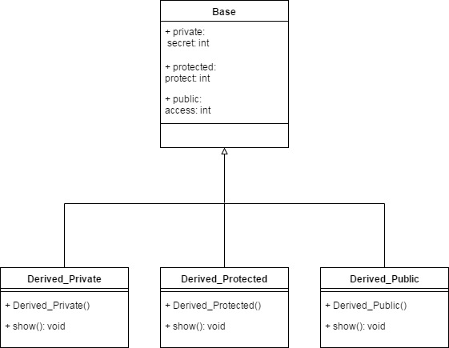
Compilation Results
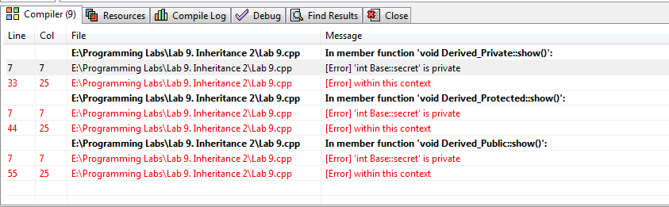
Practice Question:
Develop a simple vehicle management system in C++ using different types of inheritance: public, private, and protected.
Tasks to do:
- Create the Vehicle class
- Include a protected int speed and a public method drive() that prints the speed.
- Create the Car class
- Inherit from Vehicle using public inheritance
- Add a numberOfDoors member
- Add a public method showDetails() that prints speed and numberOfDoors.
- Create the SportsCar class
- Inherit from Car using private inheritance
- Add a public method enableTurbo() that prints "Turbo enabled!"
- Use drive() inside enableTurbo() if needed
- Create the ElectricCar class
- Inherit from Car using protected inheritance
- Add a batteryLevel member
- Override the drive() method to display "Driving electric car at X km/h with Y% battery"
- In your main() function, do the following:
- Create objects of Car, SportsCar, and ElectricCar
- Try calling:
- drive() on each object
- showDetails() on each object
- enableTurbo() on the SportsCar
- Observe which calls are allowed and which are restricted.
- After implementing the scenario, find answers of following questions:
- Which members were accessible in main() and which were not?
- Why was drive() accessible in some cases and not others?
- What’s the effect of private and protected inheritance on base class methods?

Lab 10: Polymorphism
Objective:
- The objective of this lab is to teach students how to implement Polymorphism in C++.
- Understand runtime polymorphism using virtual functions
- Practice function overriding in derived classes
- Use base class pointers or references to achieve polymorphic behavior
Learning Outcome:
- After this lab, students will be able to implement polymorphism.
Problem Statement
Design a payroll system for a company with different types of employees. The goal is to use polymorphism to calculate salaries for various employee roles, where each type has a different way of computing pay.
Tasks to do:
Create following classes with given data members and member functions/methods.
1. Employee (Base Class)
- Protected member: name
- Public virtual method: calculateSalary()
- Public method: displayInfo() that displays the employee name
- Constructor: Accepts a name and initializes the name member.
- Destructor: Declare as virtual to allow safe polymorphic deletion. Display message as per sample output.
2. FullTimeEmployee (Derived Class)
- Inherits from: Employee
- Additional members: basicSalary, allowance
- Overrides: calculateSalary() to return basicSalary + allowance
- Constructor: Accepts name, basicSalary, and allowance. Calls base class constructor to initialize name.
- Destructor: Display message as per sample output.

3. PartTimeEmployee (Derived Class)
- Inherits from: Employee
- Additional members: hoursWorked, hourlyRate
- Overrides: calculateSalary() to return hoursWorked * hourlyRate
- Constructor: Accepts name, hoursWorked, and hourlyRate. Calls base class constructor.
- Destructor: Display message as per sample output.

4. ContractEmployee (Derived Class)
- Inherits from: Employee
- Member: contractAmount
- Overrides: calculateSalary() to return contractAmount
- Constructor: Accepts name and contractAmount. Calls base class constructor.
- Destructor: Display message as per sample output.

In your main() function:
  - Create an array or vector of Employee* or Employee& pointing to objects of each derived class.
  - Call displayInfo() and calculateSalary() polymorphically
  - Print the salaries using only base class pointers
Sample Output
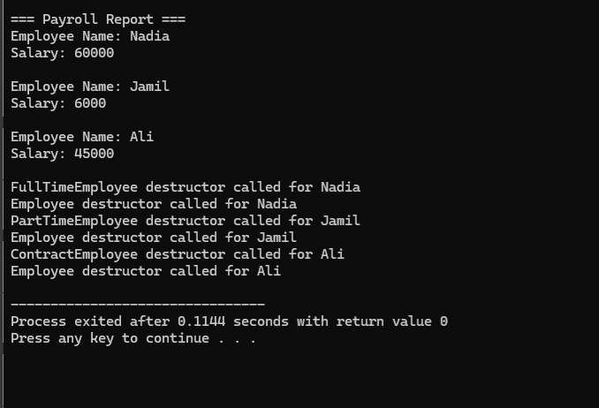
Practice Question:
Develop a notification system that can send alerts via different channels like email, SMS, and push notifications. Each notification type behaves differently when sending a message. The system must handle all notifications using polymorphism to treat them generically.
Tasks to Do:
Create following classes with given data members and member functions/methods.
- Notification (Base Class)
  - protected member: recipient
  - public virtual method: send()
  - public method: setRecipient() and getRecipient()
- EmailNotification (Derived Class)
  - Inherits from Notification
  - Overrides send() to print: "Sending Email to [recipient]"
- SMSNotification (Derived Class)
  - Inherits from Notification
  - Overrides send() to print: "Sending SMS to [recipient]"
- PushNotification (Derived Class)
  - Inherits from Notification
  - Overrides send() to print: "Sending Push Notification to [recipient]"
In your main() function:
  - Create an array or vector of Notification* pointing to objects of each derived class
  - Set a recipient for each notification using setRecipient()
  - Loop through the collection and call send() polymorphically
Observation:
Remove the virtual keyword from the base class method and observe the effect on output.

Lab 11: Class and Function Templates
Covering Lectures: 32 - 33
Objective:
- This Lab aims to give students a deep understanding of Functions and Class templates.
Learning Outcomes:
- After completing this lab, students can practice generic programming in their programs.

Problem Statement:
You are required to develop a generic inventory management system in C++. Design a system that can store and manage different types of products such as Books and Electronics using generic code.

Requirements:

1. Product Classes (Non-template)
Define two product classes with different attributes:
- Book with data members: title, author, price.
- Electronic with data members: name, brand, price.
Each class must implement:
- A default constructor
- A parametrized constructor
- A method to display details
- A getter for price

2. Class Template Inventory<T>
Create a class template to manage an array of any product type:
- addItem(T)
- displayItems()
- getItems()
- getCount()

3. Function Template findMax<T>
Write a function template that takes an array of items and returns the one with the maximum price using getPrice() method.

4. In main():
- Create inventories for Book and Electronic.
- Add multiple products using addItem().
- Display items.
- Find and display the most expensive item in each inventory.

Sample Output:
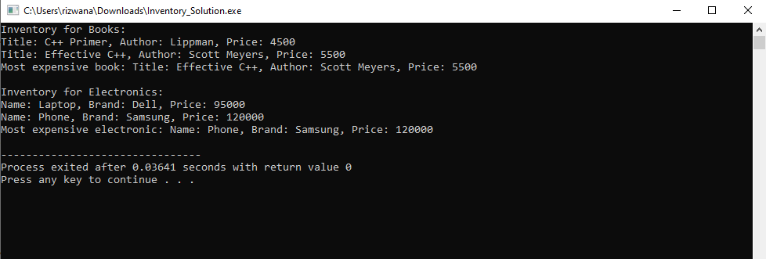

Practice Questions:
- Write a C++ code for swapping the data of two variables. The variables can be of any type (int, float, char etc.) using the function templates.
- Write a C++ Program to find the Sum of an Array using a class template. The array elements can be int, float, and double types. Character type data is not allowed.
- Write a C++ Program to find the Square of a number using a single template class. The number can be an integer, float, or double data type.

Lab 12: Class Templates, General, Partial, and Complete Specialization
Covering Lectures: 34 - 36
Objective:
This Lab aims to give students a deep understanding of General, Partial, and Complete Specialization concepts.
Learning Outcomes:
After completing this lab, students can practice General, Partial, and Complete Specialization in programs.

Problem Statement:
Write a C++ code for a generic class “Container” that stores two values of potentially different types. The goal is to demonstrate:
- Complete Specialization for Container when both values are bool. This specialization should handle Boolean-specific logic, such as counting how many true values are stored.
- Partial Specialization for Container when one value is always an integer. This should enable additional operations, like comparing the two values.
Tasks:
Implement the following:
- A general Container class template that stores two values of types T1 and T2.
- A complete specialization for Container<bool, bool> that adds a function countTrue() to count the number of true values stored.
- A partial specialization for Container<int, T> (when one value is always of the type int and the second value can be of any data type), which adds a method isEqual() to check if the two values are equal or not.
- All classes should have print() function to display the values of the variables on the screen.
- Write a main() function to demonstrate the general template, partial specialization, and complete specialization according to the sample output as given below.
Sample Output:
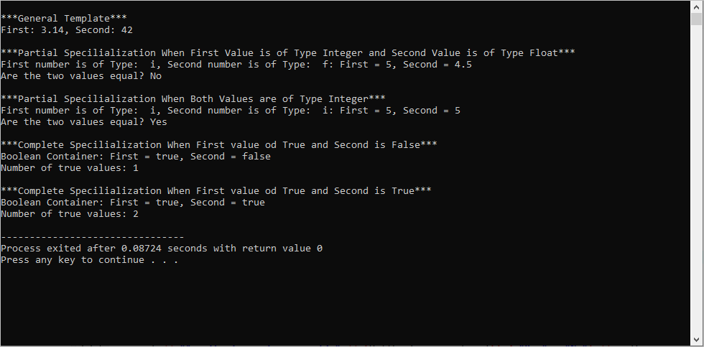
Practice Questions:
- Write a C++ program to manage different types of delivery vehicles. You have to write
  - A generic template for deliveryvehicles with two values of types “VehcileType” and “FuelType” and a print () function. The print () function will display the line “General Delivery Vehicle”, the name, and the fuel type of the vehicle.
  - You want to handle trucks differently from other vehicles so write a specialized deliveryvehicles class for Trucks and FuelType and a print () Function. The print () function will display the line “Truck Delivery Vehicle”, the name, and the fuel type of the vehicle.
  - You want to handle electric bicycles in a completely specialized way, as they are a special case compared to other vehicles.

Lab 13: Templates, Inheritance, Friends
Covering Lectures: Lectures 37 - 38
Objective:
This Lab aims to give students a deep understanding of the basic use of
- Templates and Inheritance in C++
- Templates and Friends in C++
Learning Outcomes:
After completing this lab, students can practice different types of templates with the inheritance and Friends.

Part a.
Problem Statement:
Write a C++ code for a template-based class Shape with two derived classes Rectangle and Circle. Derived classes are also template classes.
- Define a base class Shape with a pure virtual function getArea() to calculate the area.
- Define two derived classes:
  - Rectangle that calculates the area of a rectangle (length * width).
  - Circle that calculates the area of a circle (π * radius^2).
- Write a main function that:
  - Creates two instances of Rectangle class with double and integer datatypes.
  - Creates two instances of Circle class with double and integer datatypes.
  - Call the getArea() function with all the instances of both classes as per the sample output.
Sample Output:
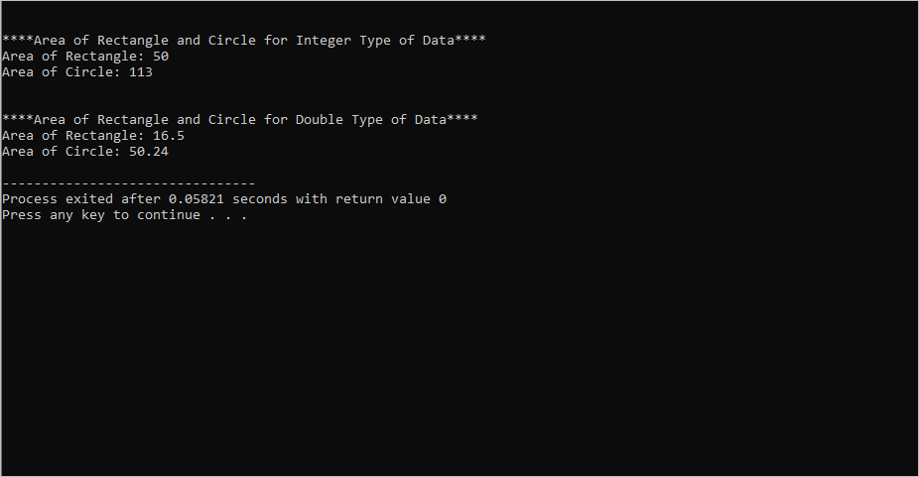
Part b.
Problem Statement:
Write C++ code for the following template readData and Subtract classes.
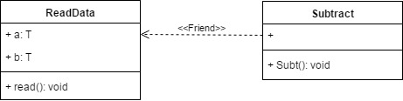
Subtract class is the friend of the ReadData class and can access the private data members of the Subtract class.
The read() method of the Subtract class takes input from the user for both data members.
In the Subt() function create two objects of ReadData for int and float, perform subtraction on the data for both objects, and print the result for each datatype.
Sample Output:
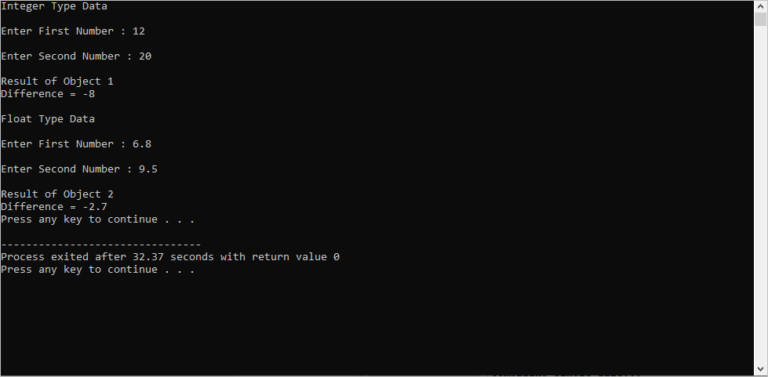
Practice Questions:
- Question 1: Write a C++ code
  - for a non-template class Color with data member mcolor and getter() and setter() functions. The setter() function will set the mcolor value. The getter() function will return the name of the color.
  - For a template class Circle inherited from the class Color. The Circle class has data member radius.
  - In the mian () function create the objects of class Cirle for int and double datatypes and set the values of radius and color. Display the values of both variables using the Circle class objects.
- Question 2: You are working on a banking system that manages various bank accounts (e.g., savings, checking, etc.). Create a template class Account<T> to store account details, where T can represent different currencies (like USD, EUR). Also, create a BankManager class to manage accounts in any currency and modify account balances.
Requirements:
  - Use templates to define the Account<T> class.
  - The BankManager class should access and modify the balance of any Account<T> object, no matter what type T is.
  - The BankManager class should be a friend of Account<T>.

Lab 14: Containers and Cursors
Covering Lectures: Lectures 40 - 42
Objective:
This Lab aims to give students a deep understanding of various STL containers in C++.
Learning Outcomes:
After completing this lab, students can practice sequence, associative, and container adapters and explore their properties and use cases.

Problem Statement:
Design a mini-library system that uses multiple STL containers:
- Use a map to store books with the book title as the key and the book's information (author, publication year, etc.) as the value.
- Use a queue to manage a waiting list for borrowing a book.
- Use a vector to store the list of currently available books.
- Implement functionality for adding books, borrowing books, and managing the waiting list.
Sample Output:
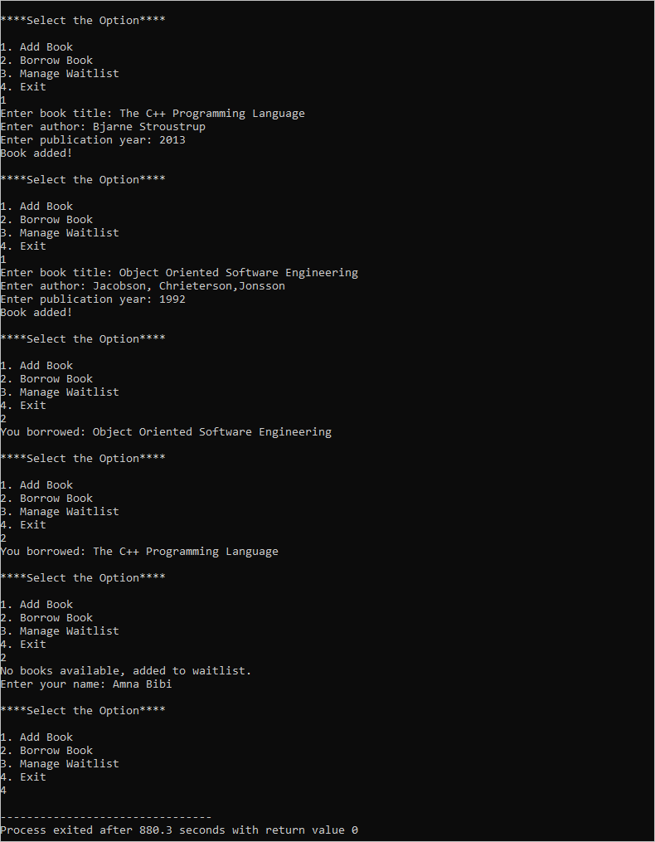
Practice Questions:
- Write a program that reads a string from the user, splits it into words, and uses set to display all unique words in the string.
- Create a task scheduler that allows the users to add tasks with different priorities (higher numbers indicate higher priority). The tasks should be stored in a priority_queue, and the program should always execute and remove the highest-priority task first.
Lab 15: Exception Handling
Covering Lectures: Lectures 43
Objective:
This Lab aims to give students a complete understanding of Error Handling techniques.
Learning Outcomes:
After completing this lab students will be able to practice different error-handling techniques:
- Abnormal Termination
- Graceful termination
- Return the illegal value
- Return error code from function
- Exception handling.
Problem Statement:
Write a C++ program to create a method that takes a string as input that must have vowels in it. For example, “Hello” is a valid input as it has two vowels ‘e’ and ‘o’ while “XYZ” is not a valid input as the string has no vowels.
Suppose a user enters a string with no vowel so arises an error. Apply the given Error handling techniques to handle this error in your program.
- Graceful termination
- Exception handling.

Sample Output:
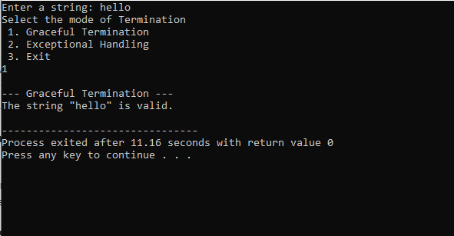

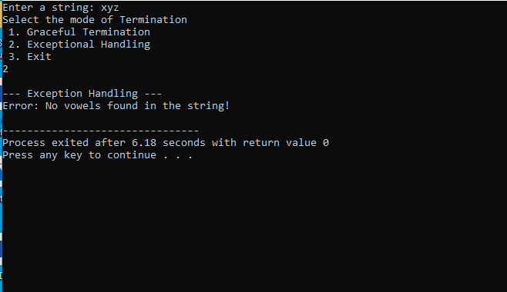

Practice Questions:
Write C++ programs for the above scenario using the given Error-Handling techniques.
- Abnormal Termination
- Return the illegal value
- Return error code from function

